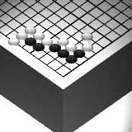
Go Club Problems 7

Liberties
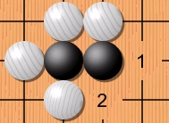
Each individual point on a Go board is called a liberty. This term is commonly used to describe the number of stones required to capture a group. For example the black group to the right has two liberties.

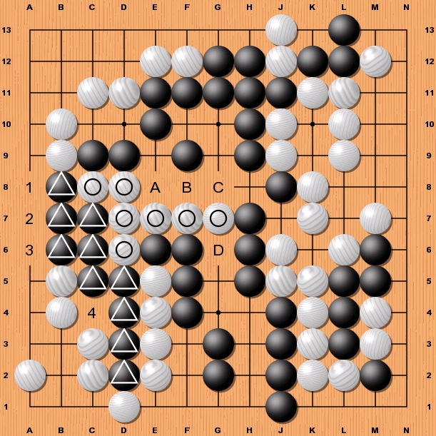

In this problem two groups, one white, one black, have been marked on the board highlighting a common occurrence in Go called a race. Both groups have the same number of liberties (4 each) meaning whoever plays will capture the other group.

There are two other such races on this weeks diagram. Whoever plays first will win the race. Can you spot them?

Solution to Problem 6
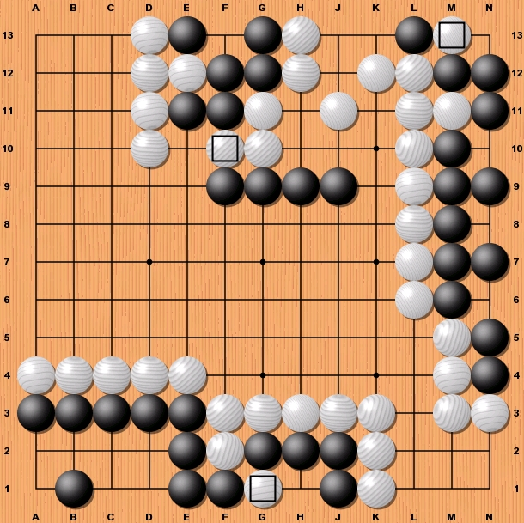
Group 1 (Top Middle)
White cuts the two black groups by playing F10. This sets up a common position in Go with the two white stones creating a gate that black cannot escape through. If black plays at E10 white plays E9.

Group 2 (Right Middle)
White must ensure that black does not make an eye in the top right hand corner as black already has one eye at N8. Playing at M13 may seem like white is sacrificing a stone but the capturing of a group always outweighs the importance of a single stone.

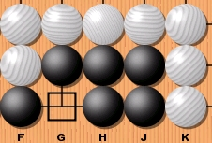
Group 3 (Bottom Middle)
Playing at G1 is a common sacrifice move. The small diagram shows what happens if black captures the stone.
Whether black plays or not the group is now dead.

