
Go Club Problems 6

Killing Groups
In the diagram below 3 Black groups have been marked with circles. White requires only 1 move to kill each of the Black groups. Can you work out where white should play?

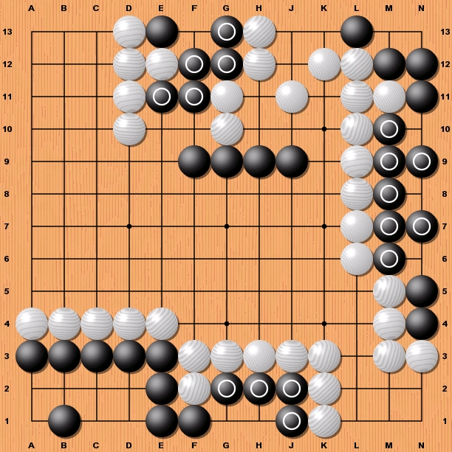

Solutions to Problem 5
All the points you should have marked are shown as letters on the diagrams. Read below for an explanation of each move.

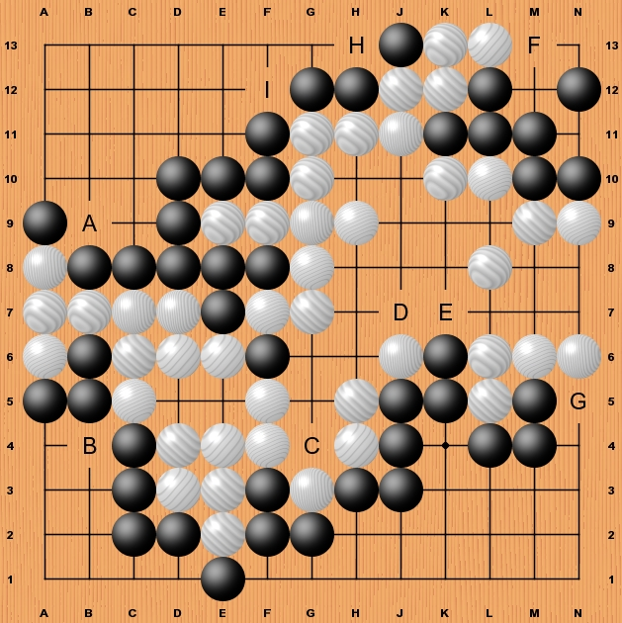
A If white plays the stone at A9 is under threat and white invades black’s territory. If black plays first the territory is safe.
B If white plays the three black stones at A5, B5 and B6 will be captured and white again invades blacks territory. Black must play first to defend.
C The white stone at G3 is under threat. White will wish to play first to defend it. Black if possible will capture G3.
D This is a real weakness in white’s position. If black plays here they invade white’s only territory with the threat on J6. If white defends at H6 black would follow with K8. White does not wish to play here as it does not solve the problem of black invading at E.
E It is vital for white that they play this move to block black’s invasion. Black would not play here as playing D would be better.
F This is a huge move for both white and black. If white plays first black’s group in the corner does not have two eyes and dies. Black must defend against this .
G This is a minor move and would probably be played as one of the last moves in the game as it is only worth 1 point. If white plays black’s area is reduced by 1. If black plays they keep the point.
H & I H is a good move for white as it captures a stone and threatens the two black stones at G12 and H12. H is not a good move for black as white would then play at I capturing the whole group of four stones. Black must defend at I. I is not worth white playing unless H has been played first.

