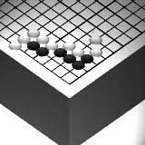
Go Club Problems 5

Is the Game Finished?
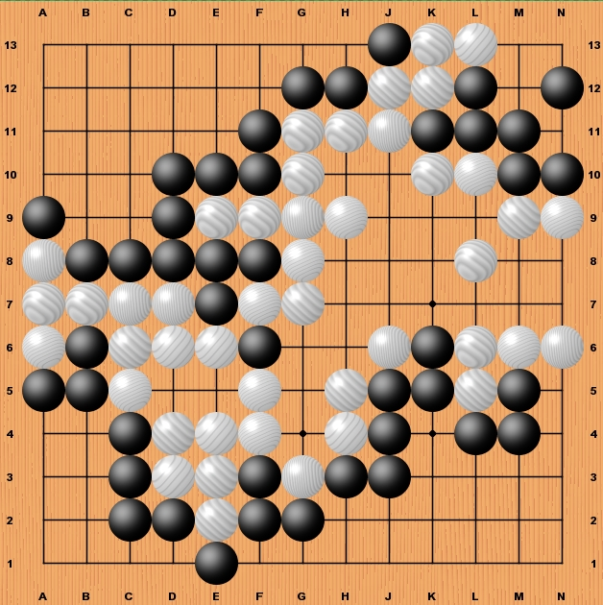
Look at the diagram below of a 13x13 game. There are no questions this week you simply have to mark all the possible moves left for black to play and all the possible moves left for white to play.
Mark the black moves with a B and the white moves with a W.

(Note – In the end game it is very common for white and black to want to play in the same place. This is because what is a threat for one player must be defended by the other. You will find that most of the time you will be marking a chosen point with a B and a W)

Solution to Problem 4
1. White has two groups, each of which has one secure eye. By playing the marked stones at C2 and F9 black prevents white from securing a second eye for each group.
2. Black has three groups. By playing the marked stones at A9, H1 and J8 white prevents black from securing a second eye for each group.
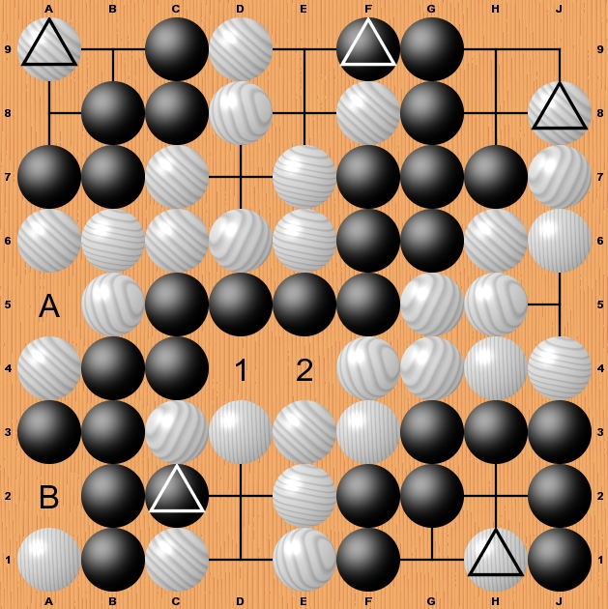
Note – In two of the above moves white is playing in the middle of a group of three points. The diagrams below explain why this prevents two eyes.

1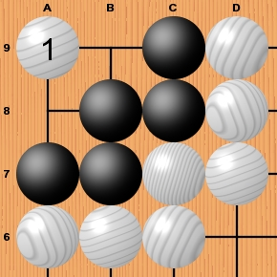 2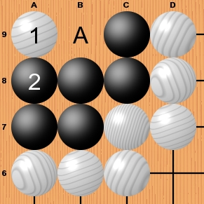 3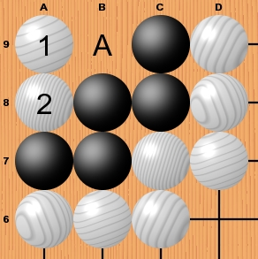 4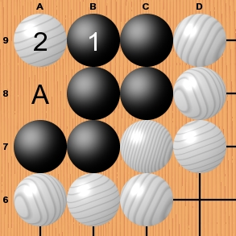 5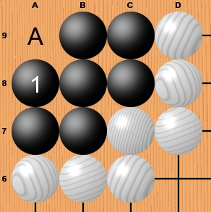
By playing at 1 white forces black to reduce their area to a single point. Look at the diagrams in sequence, the moves are marked in order. At anytime white can play A to kill black or black can play A further reducing their teritory.

3. There is one Ko on the board marked as A. Kos are position where black and white could continually remove each others stones. This is prevented by a rule in Go that a position can never be repeated. In the solution if black played at A5 white would not be able to play at A4 until they had played a move elsewhere on the board.
4. The white stone at A1 is captured. Note that B is an eye for black even though it is next to a white stone. This is because if white played at A2 they would be committing suicide.
5. The two dames have been marked 1 and 2 on the solution diagram. They are Dames because playing stones at 1 or 2 neither captures teritory nor ataris (Atari means “threaten to remove”) an adjacent group.

