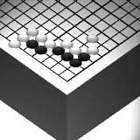
Go Club Problems 4

Two-Eyes - Second set of Problems
Below you can see a diagram of a 9x9 game. Black has three groups of stones on the board and white has two. None of the five groups mentioned has yet to secure two eyes. In this problem you will not be asked to finish the game. (The game itself is quite unrealistic and would never happen.) Simply answer the questions below.
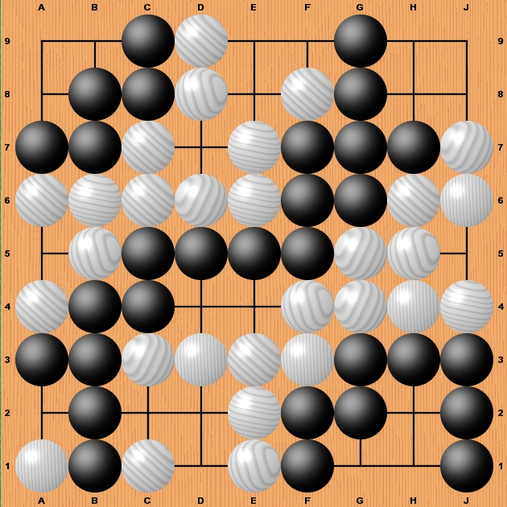

Questions
- Black can kill whites two groups by preventing each of them from getting two eyes. To kill each group requires one stone. Mark on the diagram where black would have to play to kill white.
- White can also kill blacks groups by attacking each group with one stone. Mark on the diagram where white would have to play to kill black’s three groups.
- There is one Ko on the board. Mark it with the word Ko
- There is one captured stone on the board. Mark it with an X.
- If the game ends now there are two Dames (translated as “useless points”) to be filled in. Mark them as O.

Solutions to Problem 3
Black Plays First
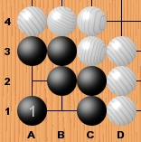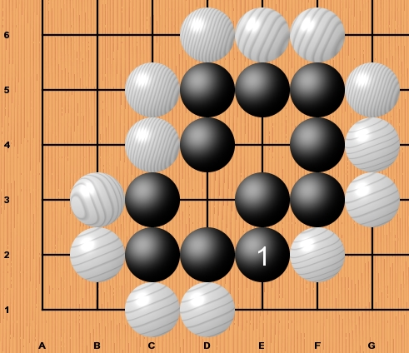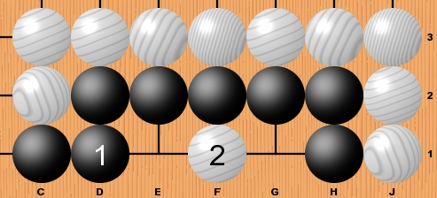
Black has two eyes Black has two eyes Black fails as white 2 prevents two eyes

White Plays First
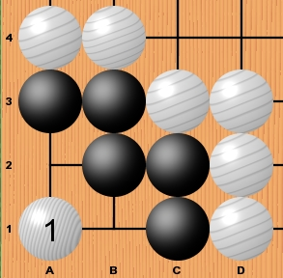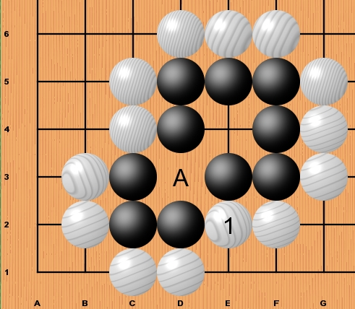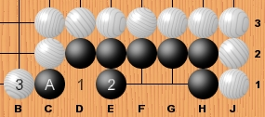
White 1 prevents two eyes. White 1 threatens the black stones White plays at 1 threatening the Black stone at A.
Black therefore dies. bottom left making A a false eye. If black takes this stone by playing at 2 there is not
As white can now play at A black enough space left for black to create two eyes.
only has one remaining eye and dies. Black only has one eye and dies.

