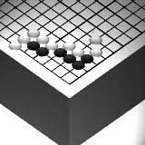
Go Club Problems 3

Two-Eyes - First set of Problems
When are stones safe? A group of stones is safe when it has surrounded two separate areas (called eyes). The stones can never be captured because playing in either of the areas would be suicide and you can’t play in both at once. Look at the diagrams below. Note that an eye can be larger than 1 point.

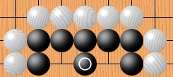
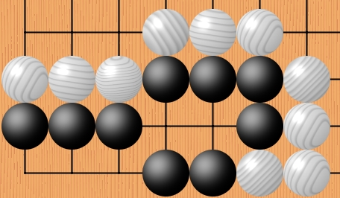

Black has two eyes in the above group
Black has two eyes in the above group.
Both eyes are larger than single points.

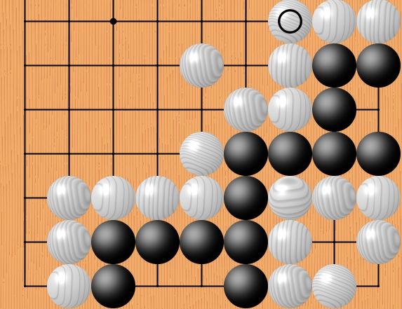

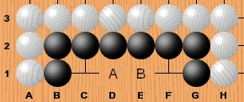

Black has the potential to make two eyes at any time they wish. If White plays in A or B black plays in the other place making two eyes. Black can only be killed if white is allowed to play two moves in a row at A and B.
Black has two eyes in the above group but has not killed the white group of stones in the corner because it also has two eyes.

Questions
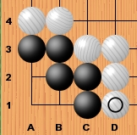
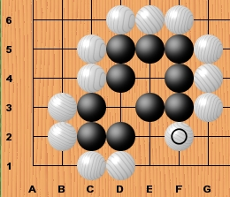
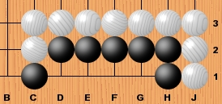
1. Which of the following black groups have two eyes if Black plays first?
2. Which of the following black groups have two eyes if White plays.
Problem 1
Problem 2

Problem 3

Solutions to Problem 2

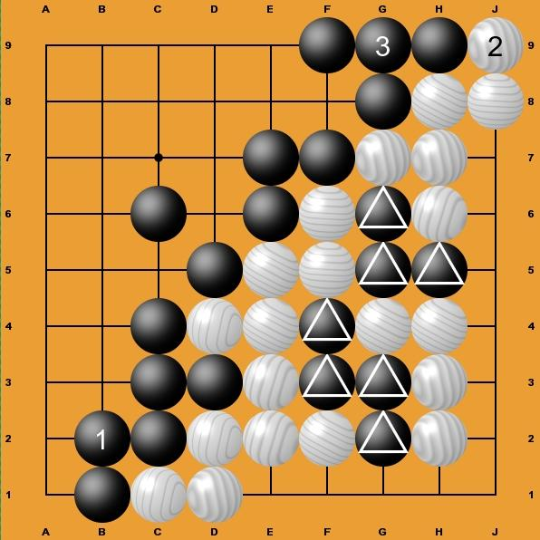
1. All the large areas on the board have been decided and there are no more large groups of stones to capture but if white plays in B2 they will capture the single stone B1 and therefore all of black’s bottom, left hand corner. Black’s first move has to be to protect this by joining at B2. White now plays J9 threatening to take black’s H9 stone. Black protects H9 by playing G9. The game is now finished.
2. White has captured a total of 7 stones (marked with the triangles on the diagram. Although the stones are not completely surrounded they can not escape capture.
Note - the number of moves required to capture a group of stones is known as it’s liberties. Both of the black groups have 1 liberty each.
3. Black’s area is not too big. If white played in it black could sqeeze them into the corner and ensure they never get two eyes
4. White spaces captured = 18
Black stones captured = 7 White’s total = 25
Black spaces captured = 27
White stones captured = 0 Black’s total = 27
Black wins by 2

