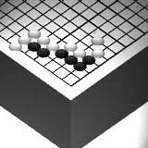
Go Club Problems 2

Black to Play
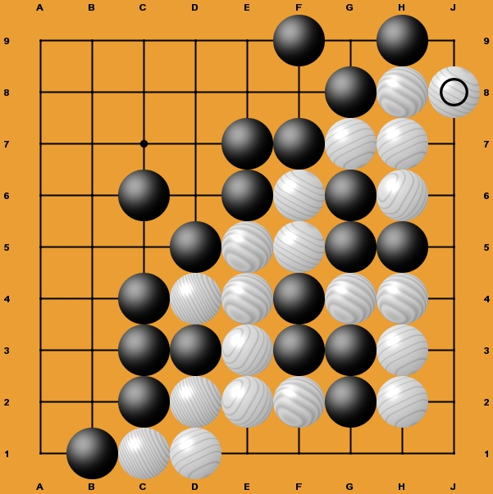

Questions

1. There are three moves left to play. What are they? (Make sure you get them in the correct order.)

2. How many stones has white captured?

3. Is black’s area too big. In other words could white play inside it and get two eyes?

4. What is the final score?

________________________________________________

Solution to Problem 1

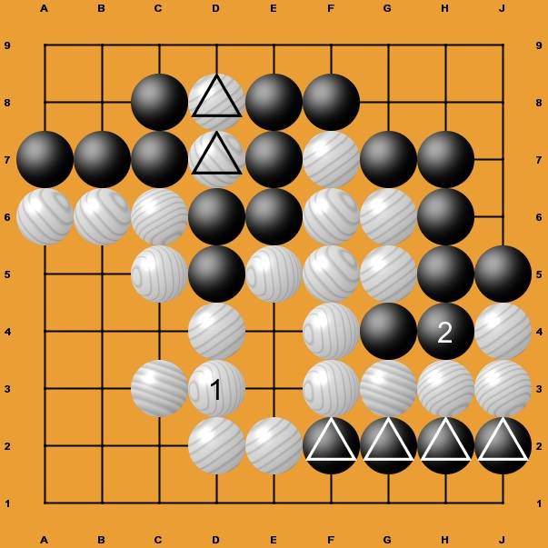
1. The most important move on the board has to be D3 (1). Black is threatening the large group of white stones on the right hand side of the board and will remove them by playing H4. By playing in D3 white removes the black stones at E3 and E4 eliminating the threat of H4.
Note - If white plays in H4 and captures G4 white dies next move because black’s next move captures the whole group by playing in the space created at G4 completely surrounding white.
2. Black plays in H4 (2) connecting and therefore saving the G4.
3. White stones captured by black = D7 & D8
Black stones captured = F2, G2, H2, J2, E3, E4 (Captured already)
(G4 is not captured as it is saved by black’s last move at H4.)
4. White spaces surrounded = 25
Black stones captured = 6 White’s Total = 31
Black spaces surrounded = 18
White stones captured = 2 Black’s Total = 20
Result is White wins by 11
Note - the score could also be calculated by taking white’s captured stones from white’s area, giving 25-2 and the same for black 18-6. The result is the same, white wins by 11. Which method you use to calculate results is up to you.

