
Go Club Problems 10

Dead or Alive?
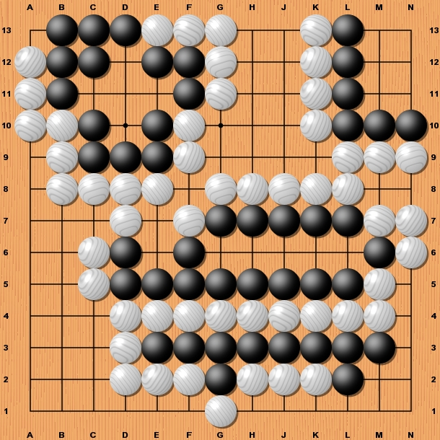

You have eight answers to find here. Four for black and four for white.

White to Play
There are four black groups under attack by white. If white can only play one move which of the black groups can be killed.

Black to Play
There are four black groups to be saved. Can black save each group?

Solution to Problem 9
Due to lack of space it is impossible to include a diagram this time. Please look up a copy of Problem 9.

The Answer | The Reasons  C - By playing K1 white has prevented the black group from getting two eyes and has there for killed the group. This is by far and away the biggest move on the board as white captures 6 black stones as well as approximately 14 points of territory. Note that if K1 is played first G2 need not be played at all as black would need to play several moves to save the group.E12 the whole corner is secured. If white plays C13 black must contain white and will lose at least 6 points of territory.  D - By playing the cut white captures 3 black stones and creates 5 points of territory.  E - Extending along the bottom like this is a very common end move game and is very effective in reducing your opponents territory. If black plays first at E12 then the whole corner is secure for black. By playing at C13 white can reduce black’s territory by at least 6 points.  B - By playing at B white not only gains 1 point of territory by forces black to lose 1 point therefore making this move worth 2 in total.  A - Playing N7 stops black pushing 1 more point into white territory. Note by playing N7 white keeps the initiative (or senti) as black must respond or lose N8.  F - By playing at F9 white encloses and gains 1 point of territory. Note black does not have to respond immediately to A4 making it a less important move than A.  G - As mentioned above, if played correctly this move is not needed making it the least important.
  Importance | Letter
  Most Important | C
   | D
   | E
   | B
   | A
   | F
  Least Important | G

