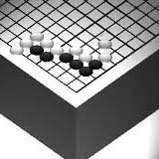
Go Club Problems

White to Play
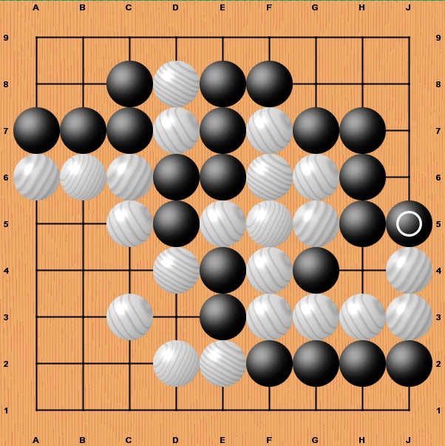

Last move played

Questions
1. Where is the most important move for white on the board?
2. There is one move left for black to finish the game after white has played. Where is it?
3. After black has played the game is finished. Name all the stones that have been captured by each player.
4. What is the final score?

